Doc No: BCIM/HYD/MS/ LH10/07
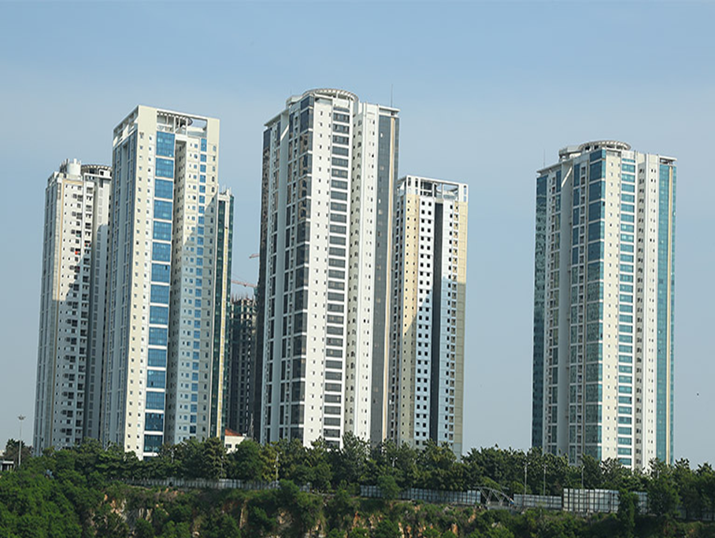
Project Name |  | LANCO HILLS RESIDENTIAL PROJECT- LH 10 ,HYDERABAD
Client |  | LANCO HILLS TECHNOLOGY PARK PRIVATE LIMITED
PMC |  | SAVILLS PROPERTY SERVICES (INDIA) PRIVATE LIMITED
Main Contractor |  | BCIM ENGINEERING PVT LIMITED
REVISION HISTORY
REV.NO | DATE |  | DETAILS OF REVISION
R0 | 21.05.2026 |  | Initial Issue for review and approval
R1 | 29.05.2026 |  | Groove thickness
PREPARED BY  BCIM |  |  | REVIEWED BY  BCIM | REVIEWED & APPROVED BY  PMC/Client

1. OVERHEAD TANK TOP WATERPROOFING
- Objective

The Objective of this Method statement is to carryout Waterproofing Treatment for OHT cover slab top locations by meeting the contract documents, Technical Data Sheet and Approved Drawings.

- Scope of Work
Providing and applying waterproofing for OHT Cover slab top areas by surface method. The work comprises treating all cracks, construction joints and surface defects, followed by applying two coats of Fosroc Brushbond Roofguard Premium solar-reflective elastomeric polyurethane waterproof coating over a primer of Nitoproof WB.

- Reference
    - Approved Drawings
    - Approved Materials

- Materials Used
S.No | Material/Product | Purpose
1 | Fosroc Brushbond Roofguard Premium | Single Component Acrylic-based modified PU elastomeric solar reflective waterproof coating
2 | Fosroc Nitoproof WB | Primer coat (Diluted 1:2 with water)
3 | Fosroc Thioflex 600 | Polysulphide sealant for expansion joints and crack sealing

- Surface Preparation & Crack / Joint Treatment
    - Inspect the entire area and identify all cracks, porous zones, construction joints, cold joints , hollow /patch and defective areas.
    - Treat all cracks: make a U groove of 5 mm wide × 10 mm deep, apply primer coating over the groove, and fill with Fosroc Thioflex 600 sealant. Allow to cure.
    - For spider cracks, web cracks or shrinkage cracks (more than 1–2 mm), treat from the negative side using two/one-component PU grouting: drill holes, fix mechanical nipples, and inject with high pressure electric grout pump
Pre-Ponding:
    - Before applying waterproofing, ensure all drain outlets are sealed/plugged. Conduct a pre-application ponding test for 24 hours to identify any active leaks; repair all identified leaks before proceeding.
    - Pre-wet the surface with clean water before application. Surface should be Saturated Surface Dry (SSD)
- Application Procedure – Fosroc Brushbond Roofguard Premium
    - After complete curing of crack/joint repairs, apply primer coat of Fosroc Nitoproof WB diluted with water in ratio 1:2 at a coverage of 8–10 sqm/litre. Allow primer to dry completely
    - Apply the FIRST coat of Brushbond Roofguard Premium using roller, brush, squeegee, or airless spray at a wet film thickness (WFT) of 0.5 mm per coat at a coverage of 0.5 litre/sqm. Ensure uniform coverage
    - Allow the first coat to dry as per manufacturer's recommendation before applying the second coat
    - Apply the SECOND coat of Brushbond Roofguard Premium in the cross direction at the same
thickness and coverage
    - Extend the coating to the full height of the parapet wall as per manufacturer's specification.
Post-Ponding:
    - After complete curing of the waterproof coating (minimum 48 hours after final coat),conduct a ponding test by flooding the sunken area with minimum 25 mm depth of water for 72hours. Check for any seepage or dampness. Clear the water only after the test is satisfactorily completed and approved by the Engineer-in-Charge.
    - Cure the completed screed for a minimum of 7 days.
Instruments:
    - Grinding Machine with accessories
    - Hammer and Chisel
    - Roller and Paint Brush
    - Drilling machine and bits
    - Injection Grouting Machine
    - Slow Speed Mixer
    - Spatula
    - Coir Cleaning Brush.

ATTACHMENT
- Check list for Waterproofing

